**A Journey with Agastya Naturals in the NEST Room**

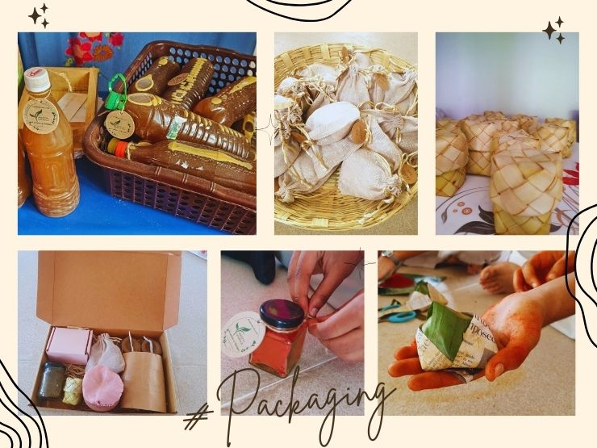

Our journey of Agastya Naturals in the NEST room began with a simple inspiration – whatever we do within the campus should be sustainable. This philosophy guided us to advise the children to preserve and reuse everything possible.

As I walk into the NEST room, I'm greeted by the lively atmosphere that reflects our wonderful journey with the children. Once, we stumbled upon some curtains and decided to paint them ourselves, giving the room a creative personal touch. Every piece of furniture here, especially the wooden racks, holds special memories of us upcycling wood and working together to create something beautiful.

[Read more….](https://www.agastyaacademy.edu.in/post/a-journey-with-agastya-naturals-in-the-nest-room)